Swinburne University of Technology

*COS20019 Cloud Computing Architecture*

*­­­*­­­­

ACF Lab 4: Working with EBS

*Sunday 30th September, 2023*

**Task 1: Create a New EBS Volume**

5. In the **AWS Management Console**, on the **Services** menu, click **EC2**

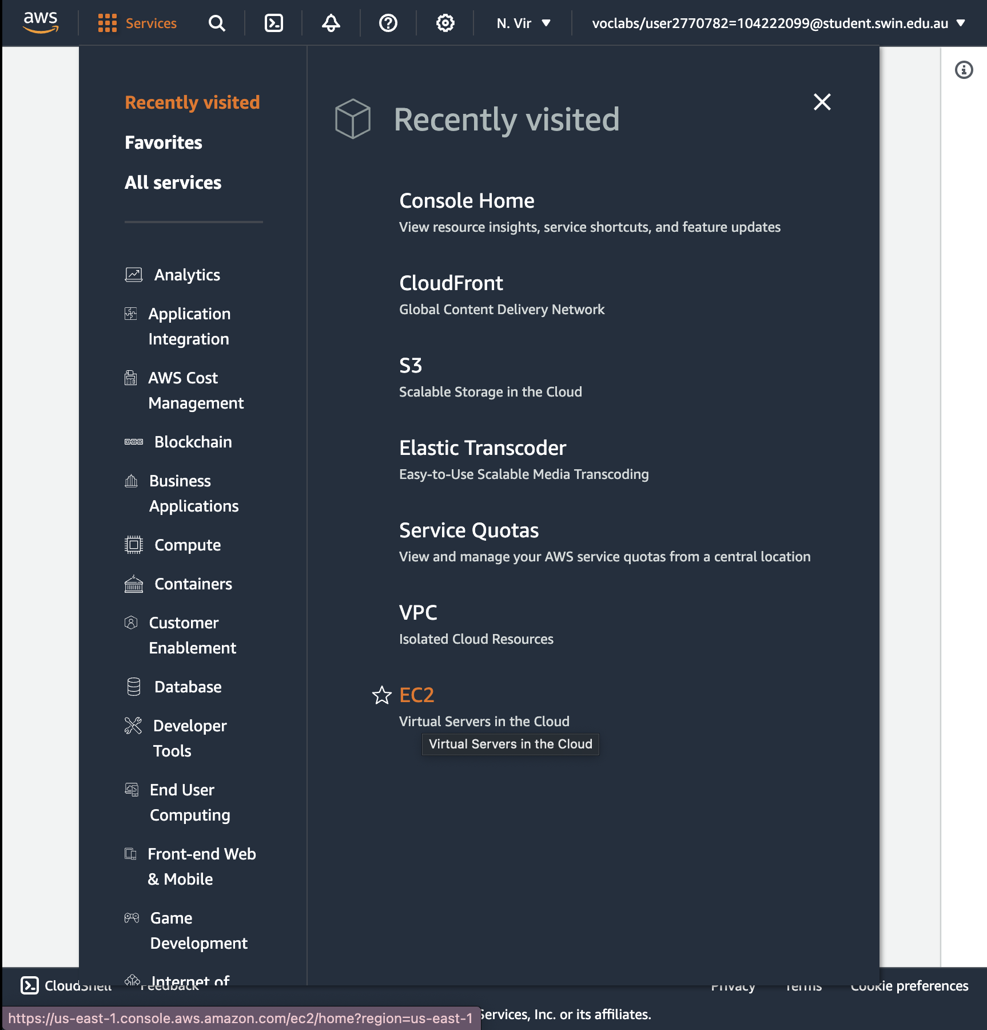

6. In the left navigation pane, choose **Instances**.

An Amazon EC2 instance named **Lab** has already been launched for your lab.

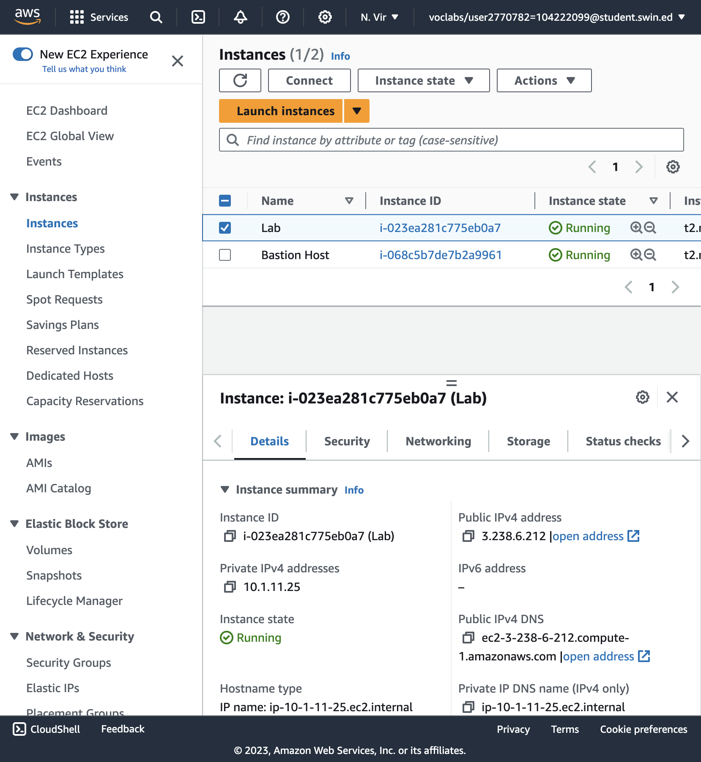

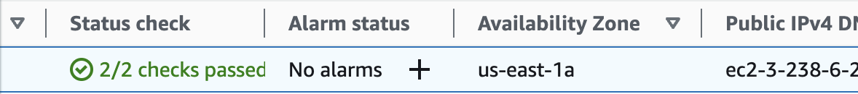

Note the **Availability Zone** of the instance. It will look similar to *us-east-1a*.

8. In the left navigation pane, choose **Volumes**.

You will see an existing volume that is being used by the Amazon EC2 instance. This volume has a size of 8 GiB, which makes it easy to distinguish from the volume you will create next, which will be 1 GiB in size.

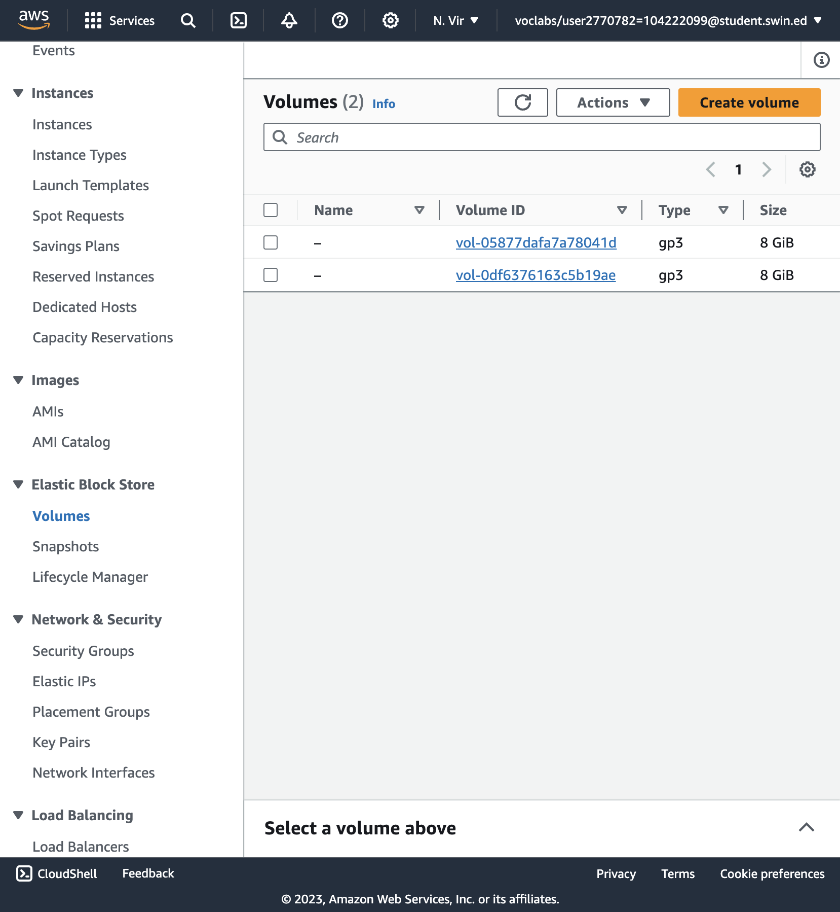

9. Choose **Create volume** then configure:

* **Volume Type:** *General Purpose SSD (gp2)*
* **Size (GiB):** 1. **NOTE**: You may be restricted from creating large volumes.
* **Availability Zone:** Select the same availability zone as your EC2 instance.
* Choose **Add Tag**
* In the Tag Editor, enter:
  + **Key:** Name
  + **Value:** My Volume

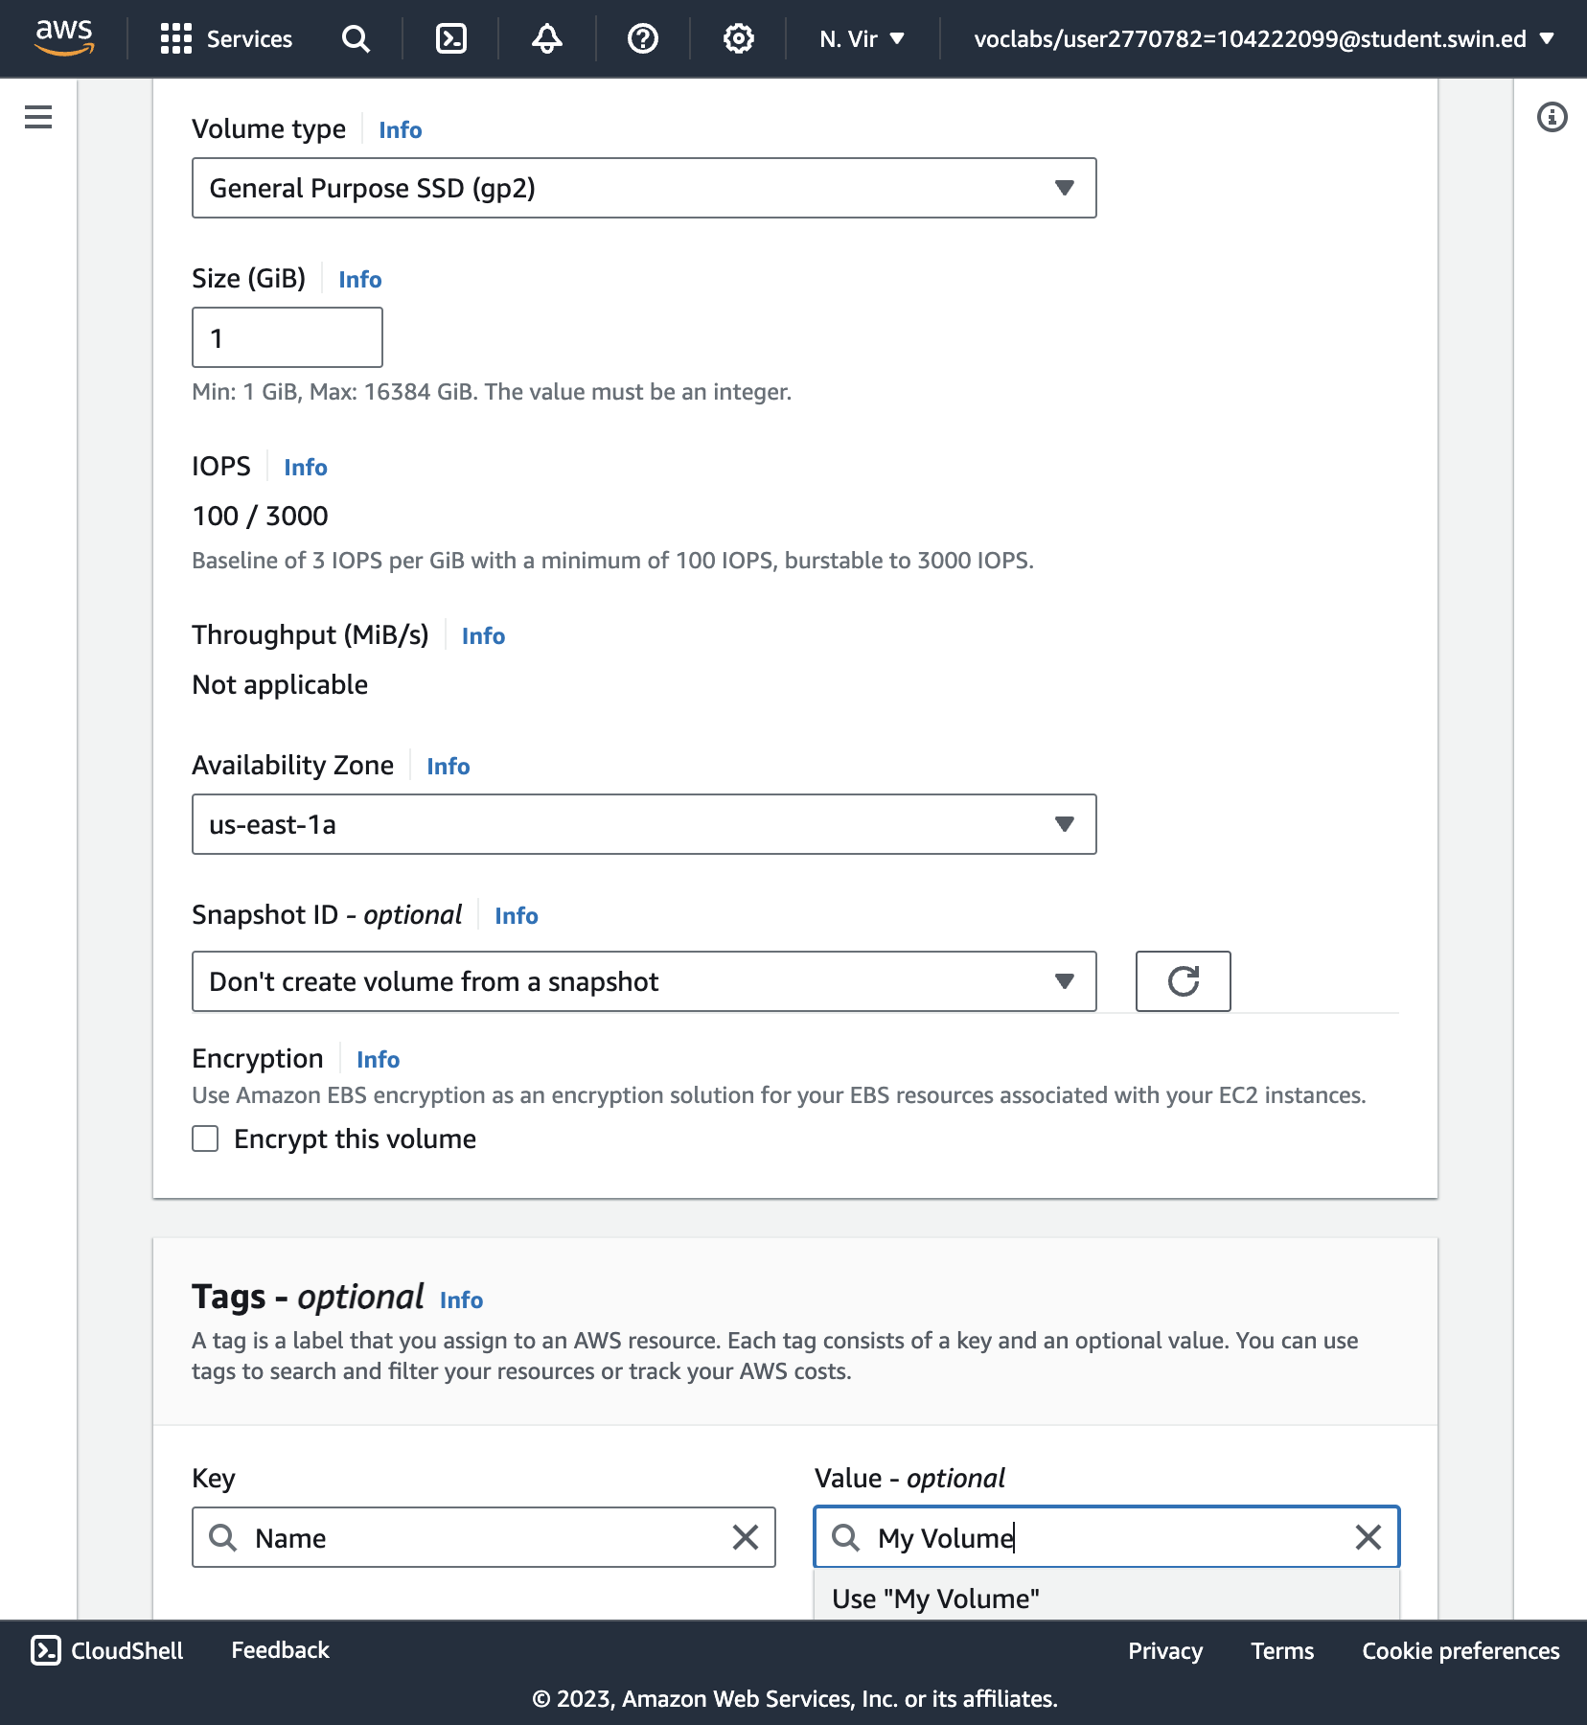

10. Choose **Create Volume**

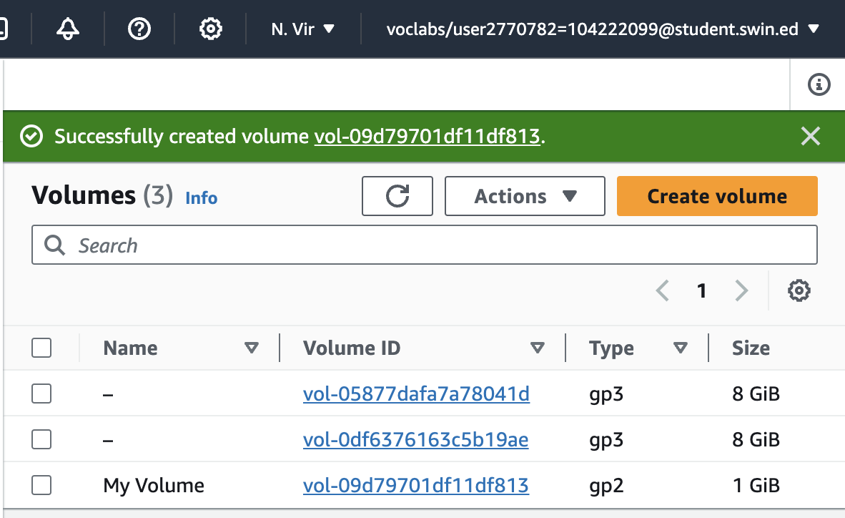

Successfully created “My Volume”

**Task 2: Attach the Volume to an Instance**

11. Select **My Volume**

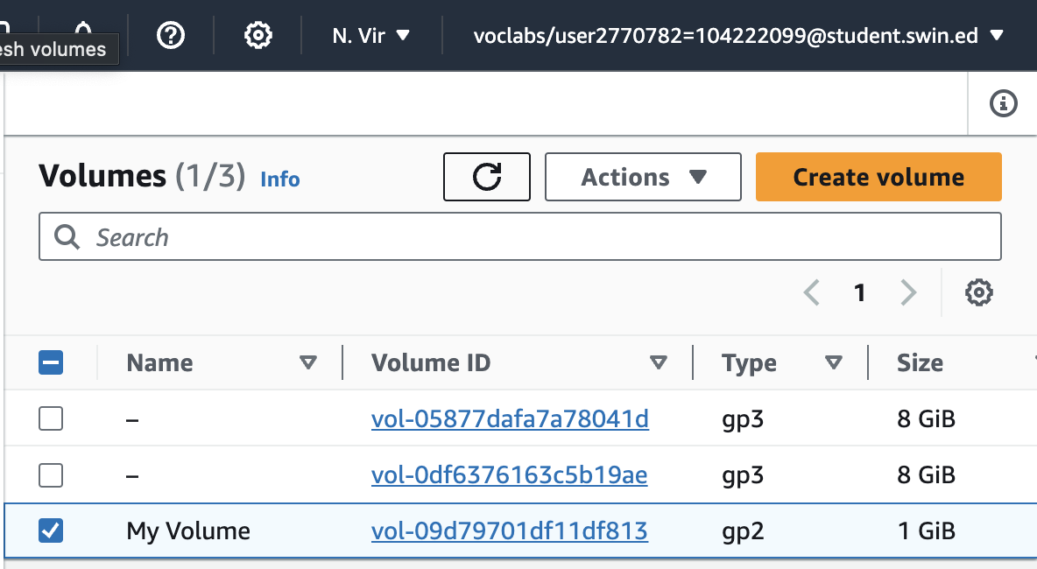

12. In the **Actions** menu, choose **Attach volume**.

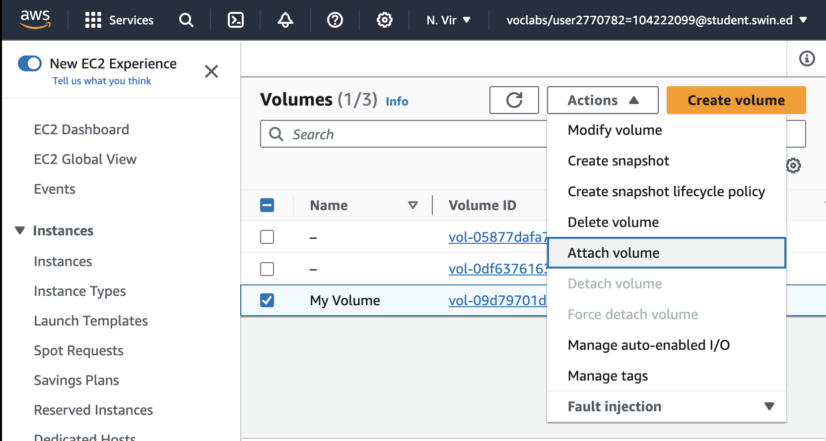

1. In the **Actions** menu, choose **Attach volume**.

1. Choose the **Instance** field, then select the instance that appears (Lab).

Note that the **Device** field is set to */dev/sdf*. You will use this device identifier in a later task.

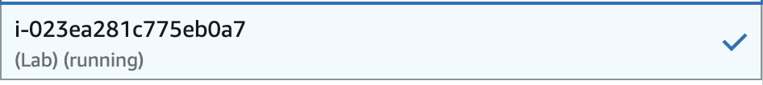

1. Choose **Attach volume** The volume state is now *In-use*.

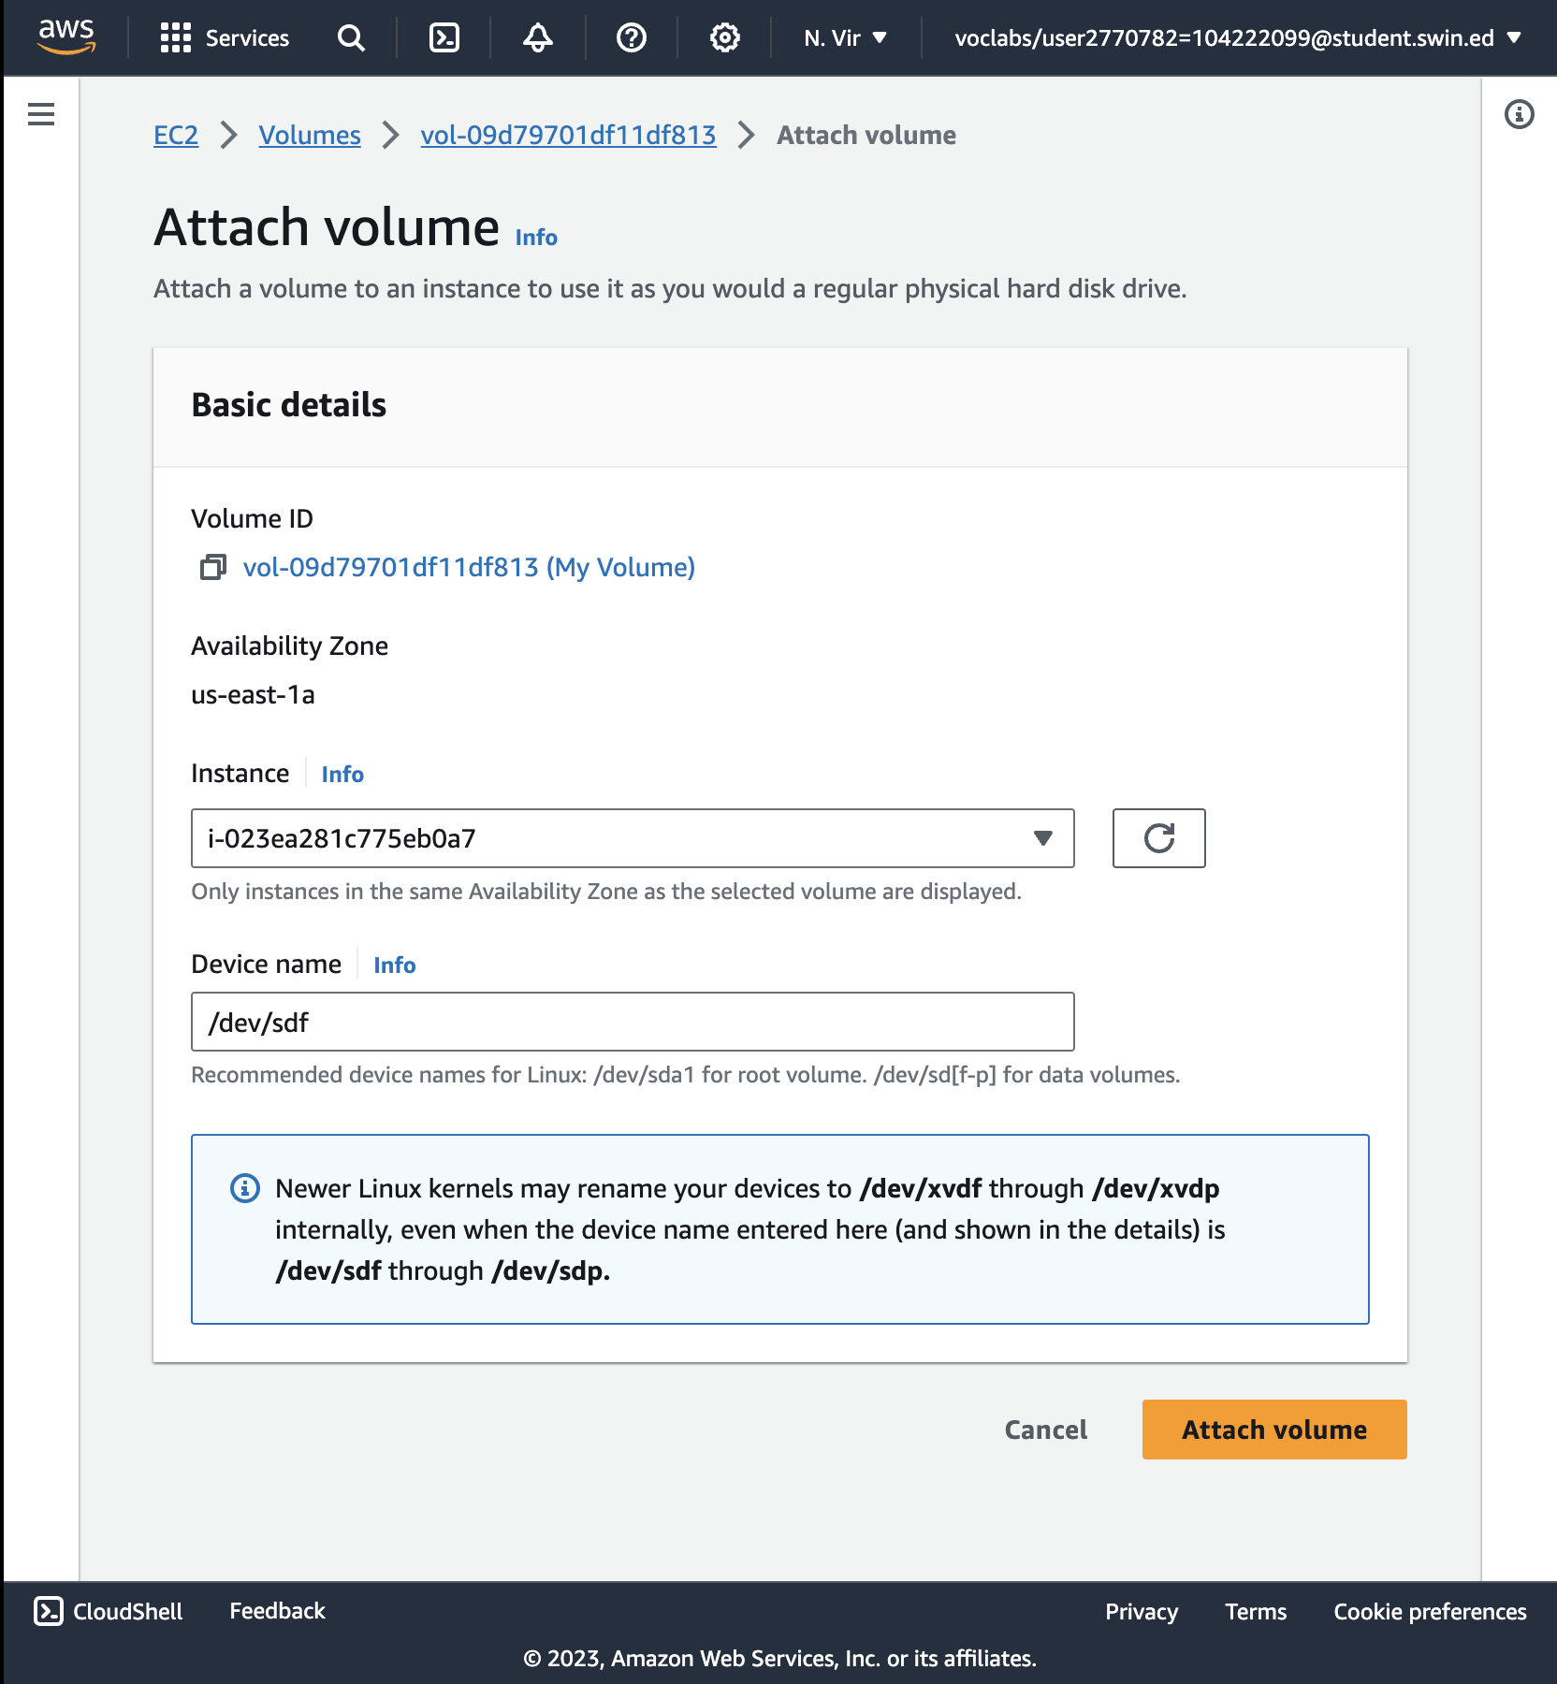

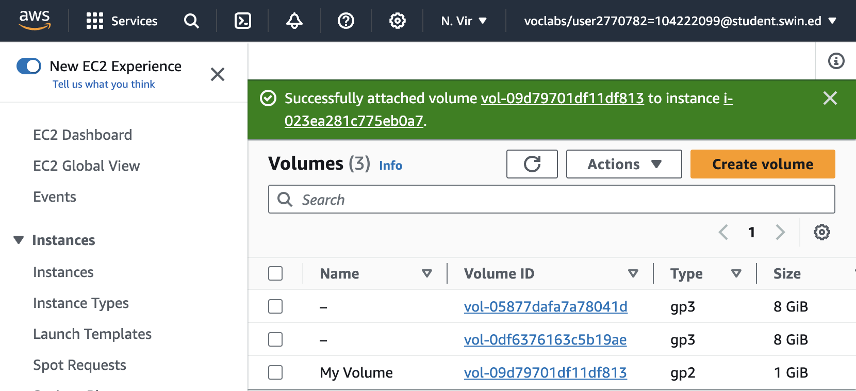

Successfully attached volume

**Task 3: Connect to Your Amazon EC2 Instance**

23. Read through all the instructions in this one step before you start to complete the actions, because you will not be able see these instructions when the Details panel is open.

* Choose the Details drop down menu above these instructions you are currently reading, and then choose Show. A Credentials window will open.
* Choose the **Download** button and save the **labsuser.pem** file.
* Then exit the Details panel by choosing the **X**.

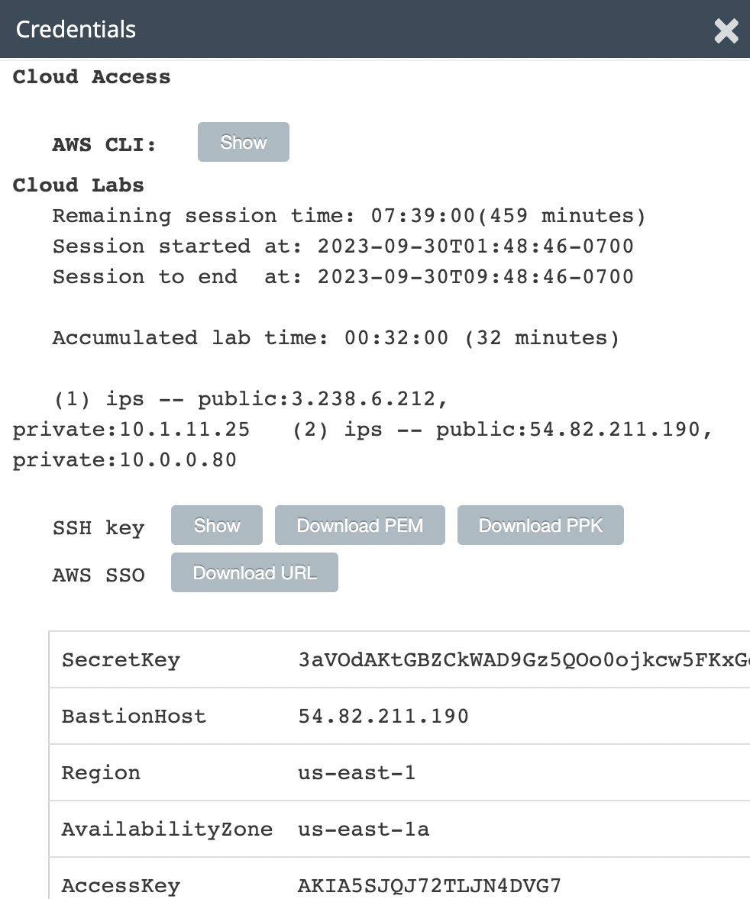

24. Open a terminal window, and change directory cd to the directory where the labsuser.pem file was downloaded.

For example, run this command, if it was saved to your Downloads directory:

**cd ~/Downloads**

25. Change the permissions on the key to be read only, by running this command:

**chmod 400 labsuser.pem**

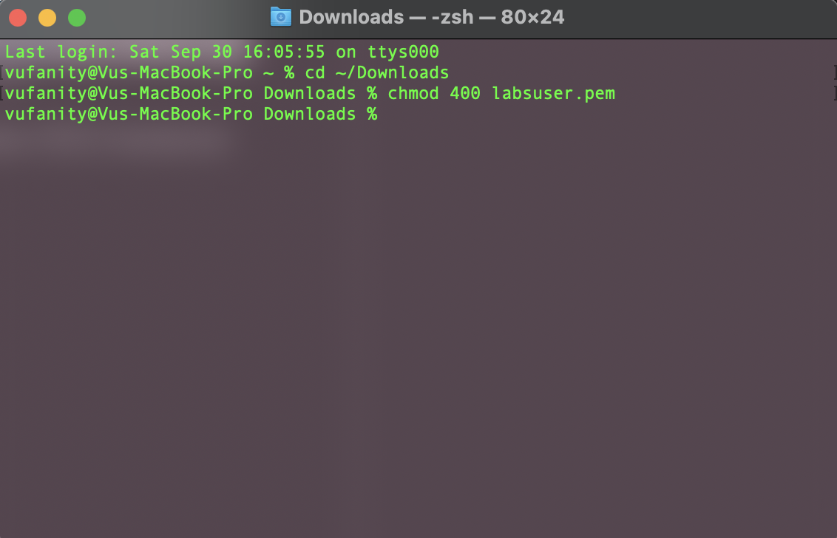

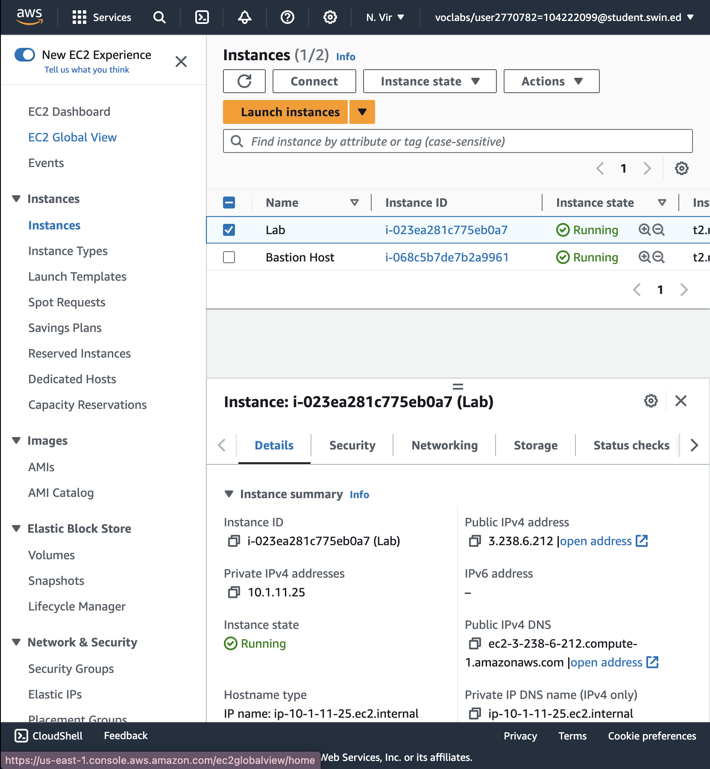

27. In the *Details* tab, copy the **Public IPv4 address** value.

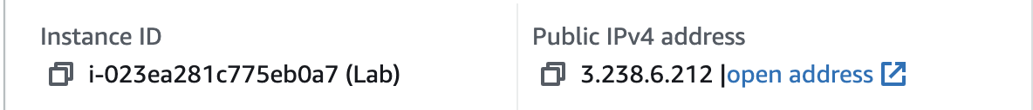

28. Return to the terminal window and run this command (replace <public-ip> with the actual public IP address you copied):

**ssh -i labsuser.pem ec2-user@<public-ip>**

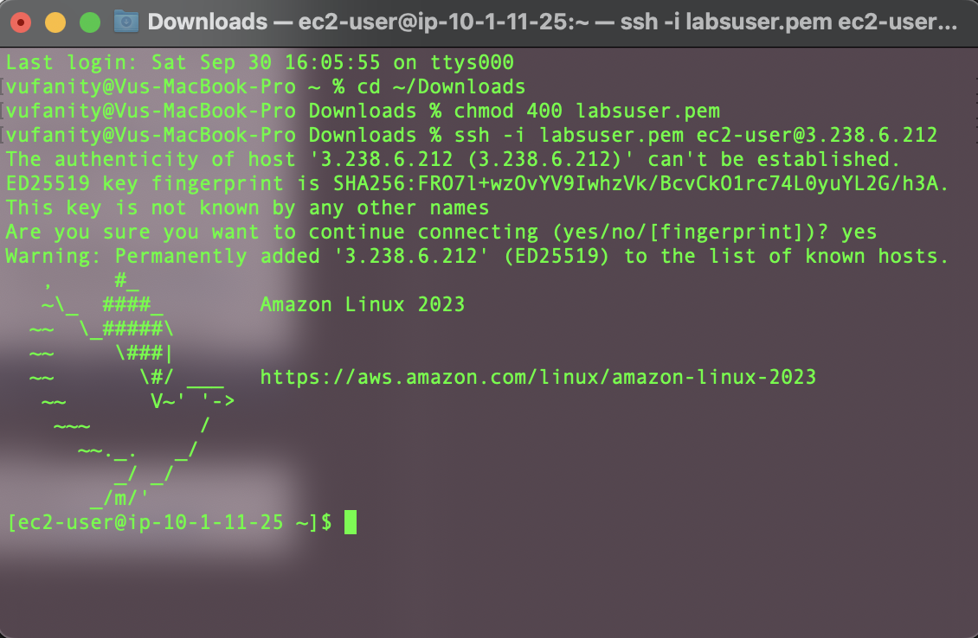

**Task 4: Create and Configure Your File System**

30. View the storage available on your instance:

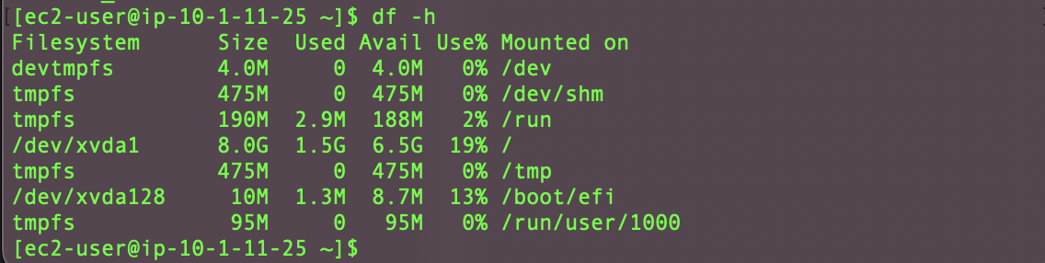

This is showing the original 8GB disk volume. Your new volume is not yet shown.

31. Create an ext3 file system on the new volume:

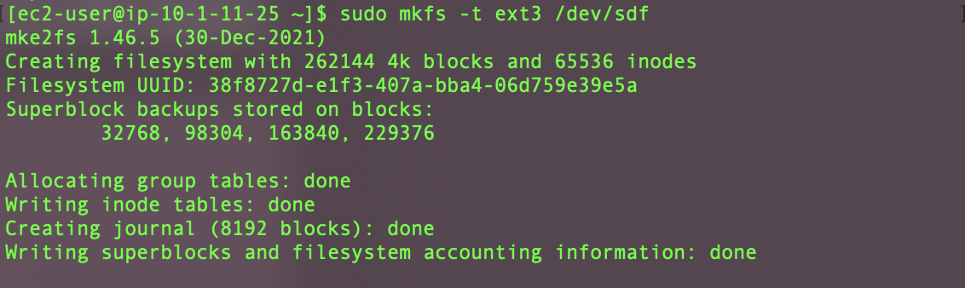

32. Create a directory for mounting the new storage volume:



33. Mount the new volume:



To configure the Linux instance to mount this volume whenever the instance is started, you will need to add a line to */etc/fstab*.

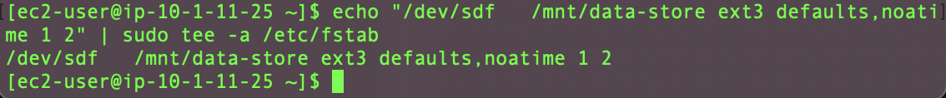

34.View the configuration file to see the setting on the last line:

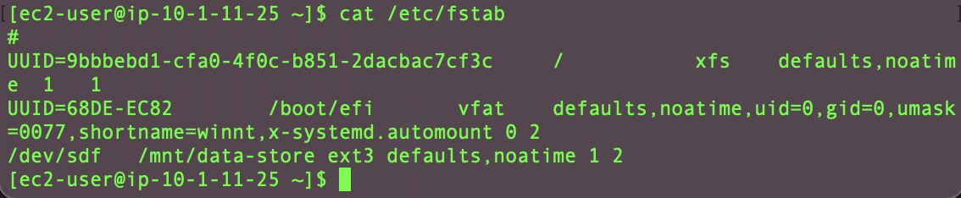

35. View the available storage again:

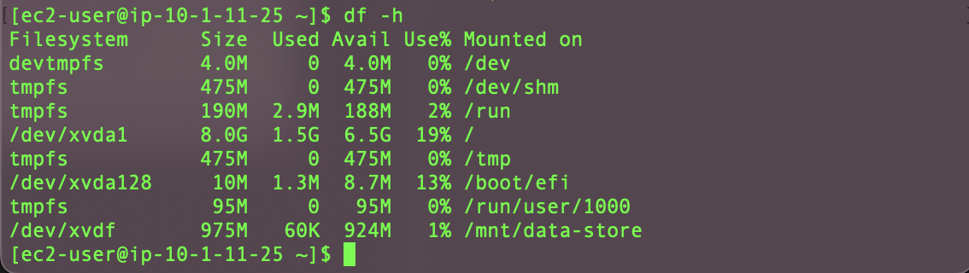

36. On your mounted volume, create a file and add some text to it.



37. Verify that the text has been written to your volume.



**Task 5: Create an Amazon EBS Snapshot**

38. In the **AWS Management Console**, choose **Volumes** and select **My Volume**.

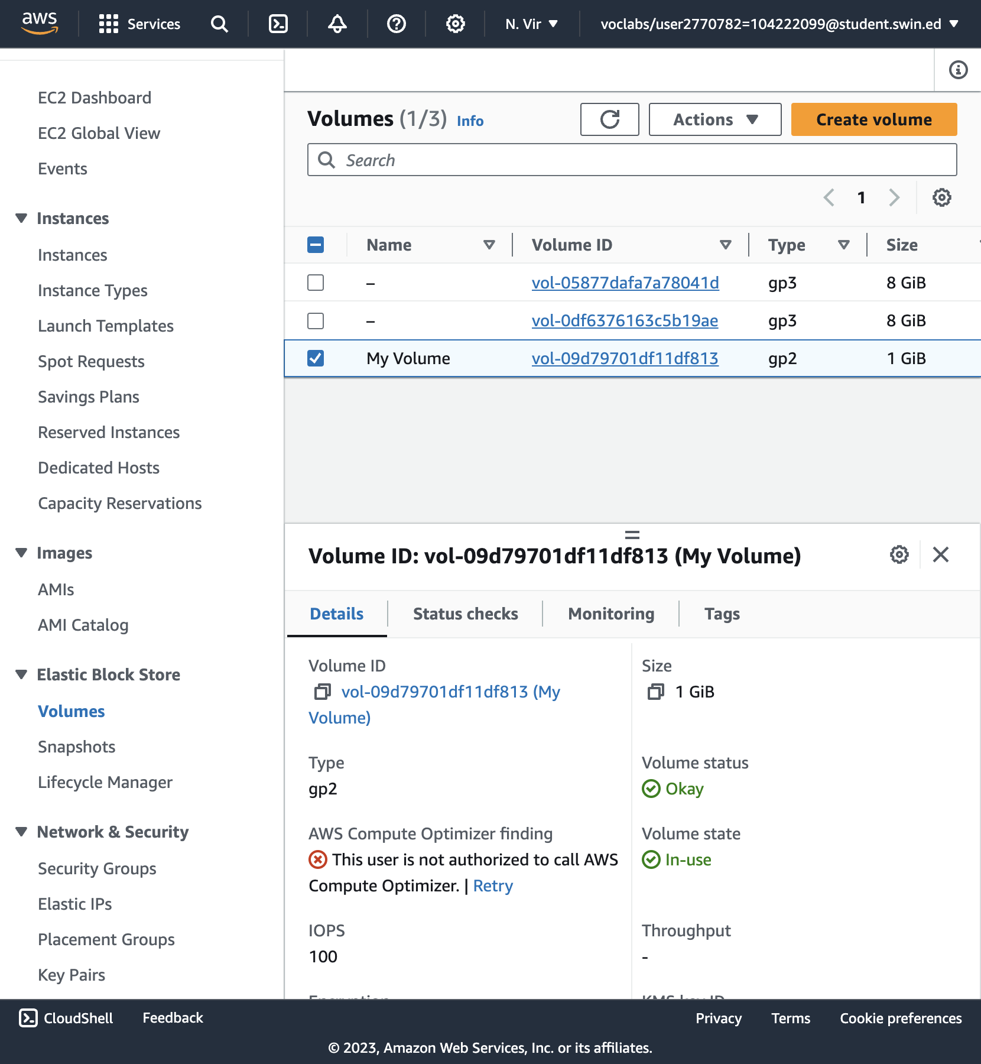

39. In the **Actions** menu, select **Create snapshot**.

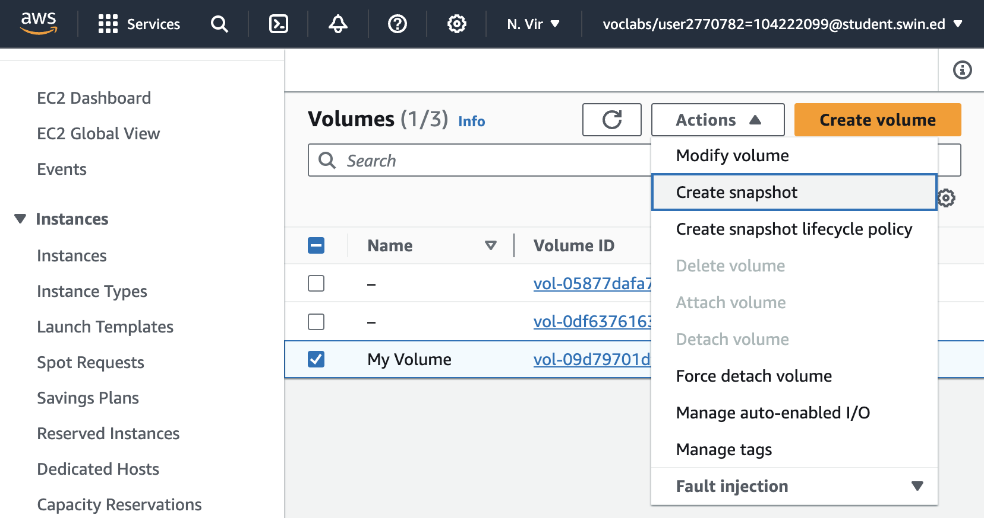

40. Choose **Add tag** then configure:

* **Key:** Name
* **Value:** My Snapshot
* Choose **Create snapshot**

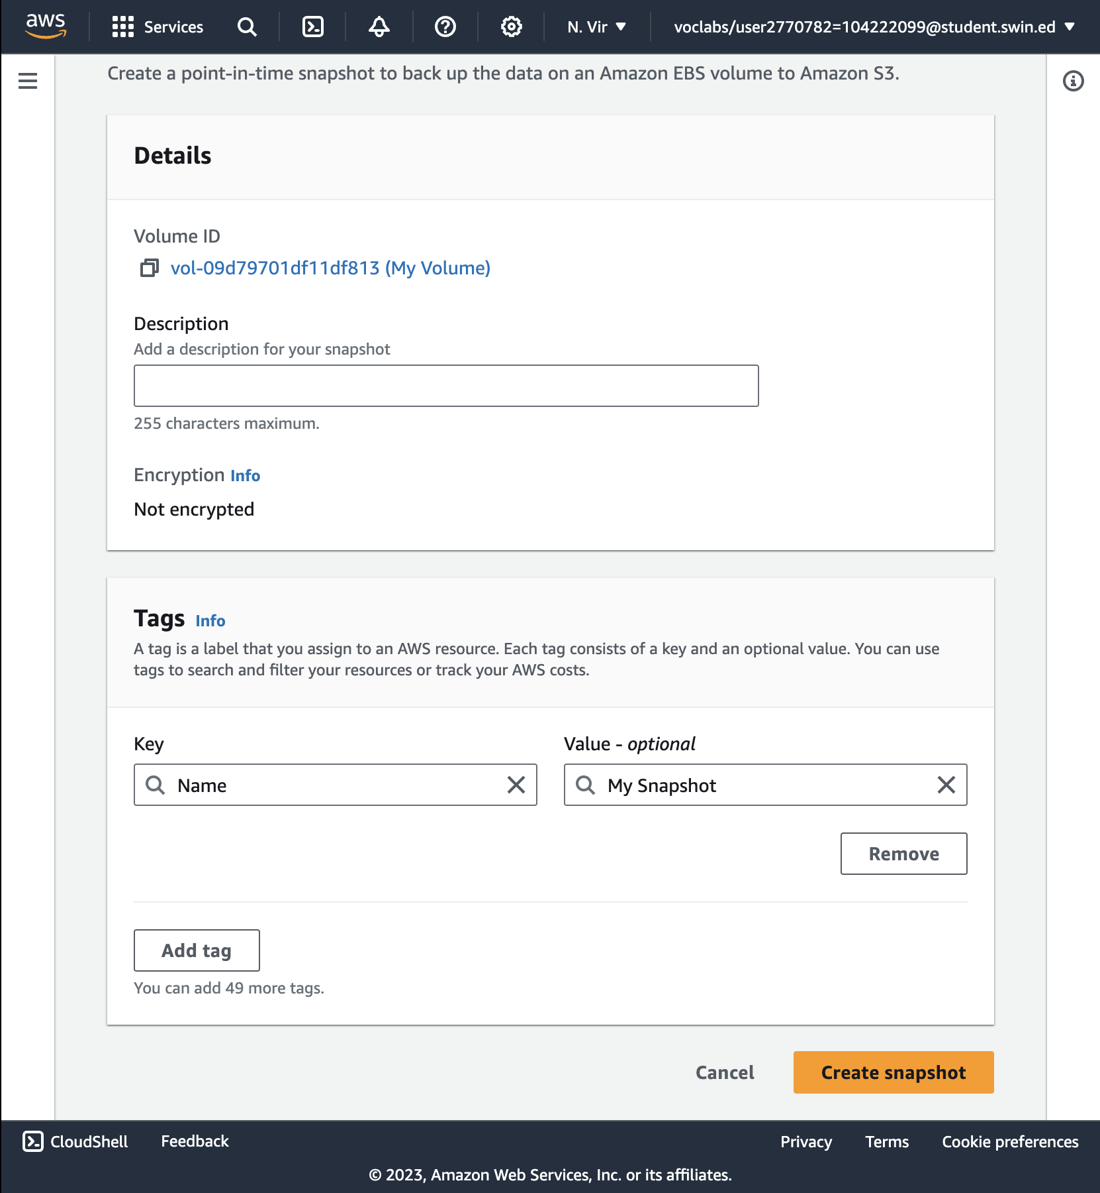

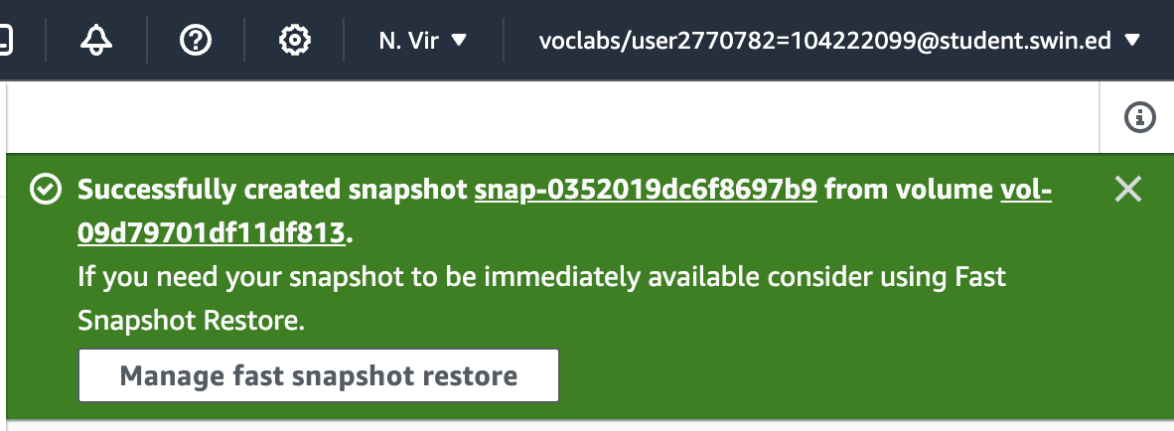

Successfully created snapshot

41. In the left navigation pane, choose **Snapshots**.

Your snapshot is displayed. The status will first have a state of *Pending*, which means that the snapshot is being created. It will then change to a state of *Completed*.

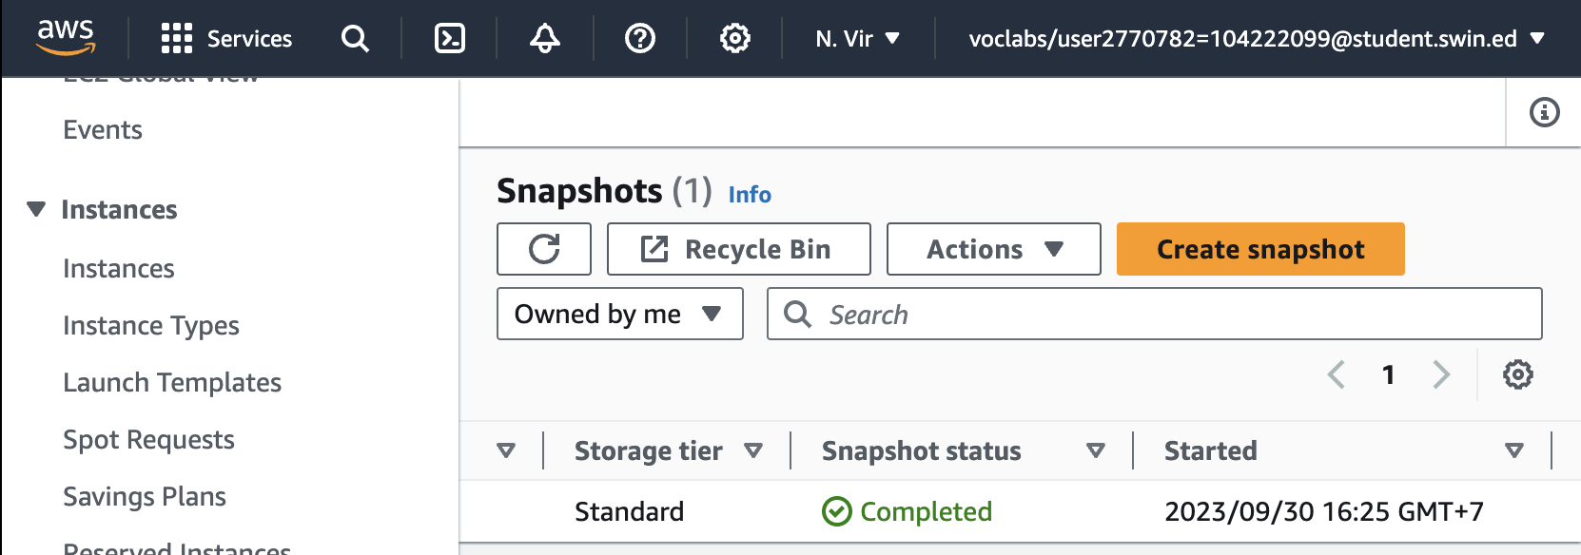

42. In your remote SSH session, delete the file that you created on your volume.



43. Verify that the file has been deleted.



**Task 6: Restore the Amazon EBS Snapshot**

**Create a Volume Using Your Snapshot**

44. In the **AWS Management Console**, select **My Snapshot**.

45. In the **Actions** menu, select **Create volume from snapshot**.

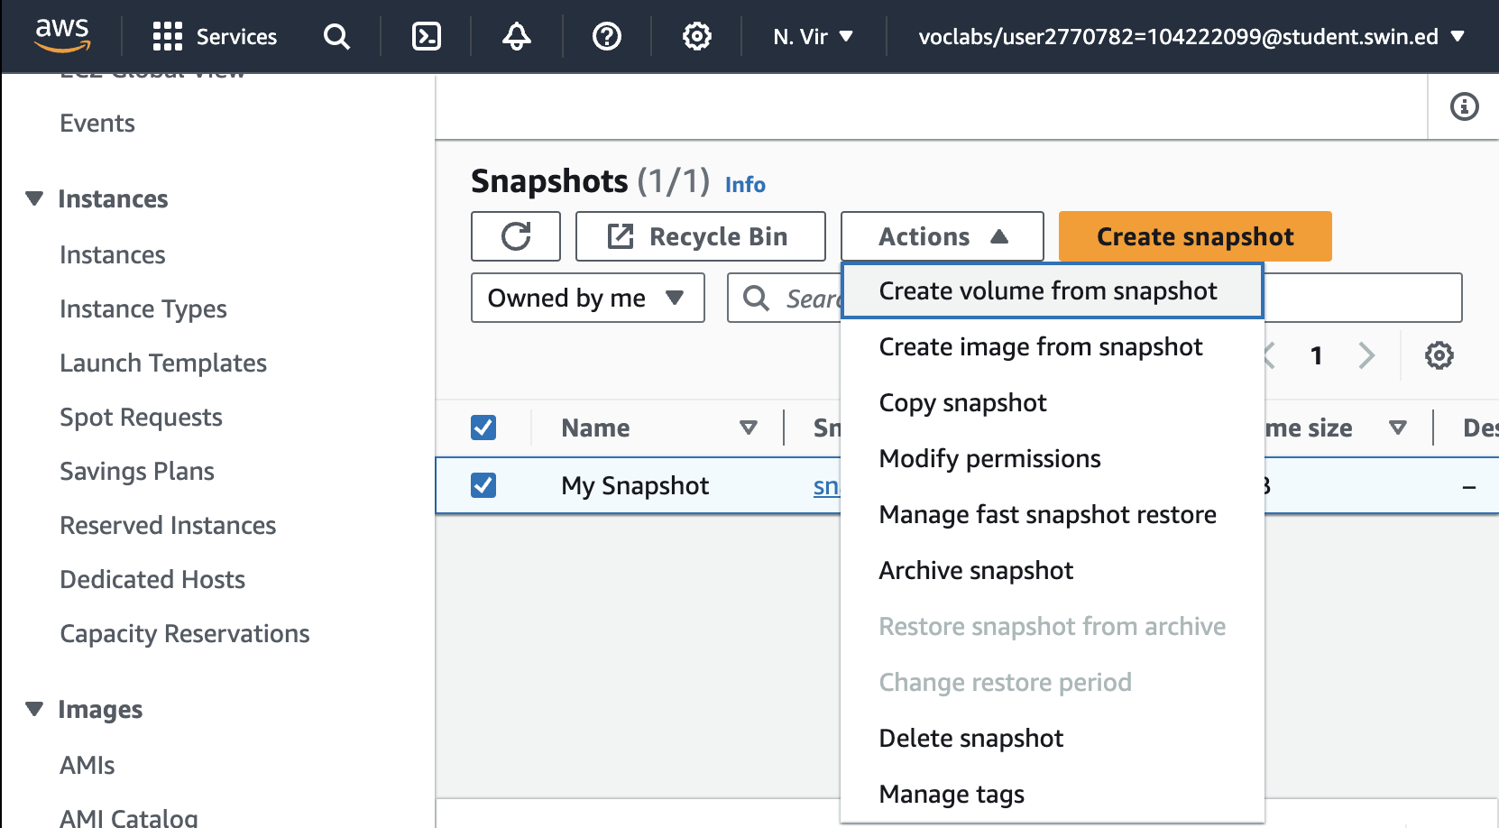

1. For **Availability Zone** Select the same availability zone that you used earlier.

1. Choose **Add tag** then configure:

* **Key:** Name
* **Value:** Restored Volume
* Choose **Create volume**

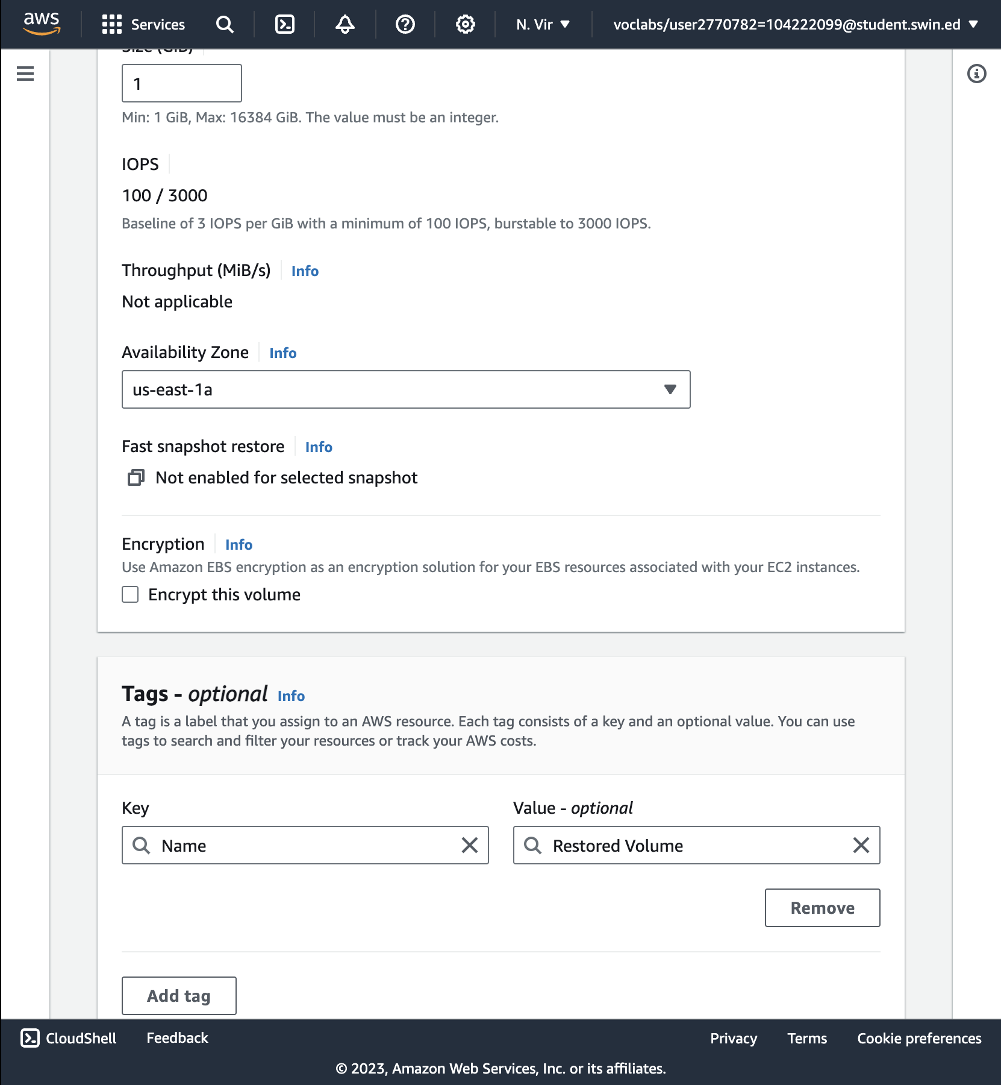

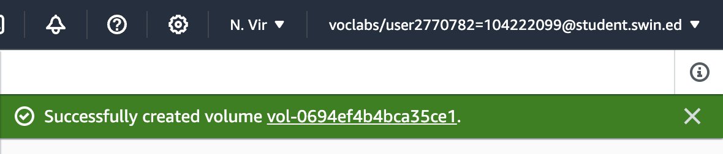

Successfully created volume from snapshot

**Attach the Restored Volume to Your EC2 Instance**

48. In the left navigation pane, choose **Volumes**.

49. Select **Restored Volume**.

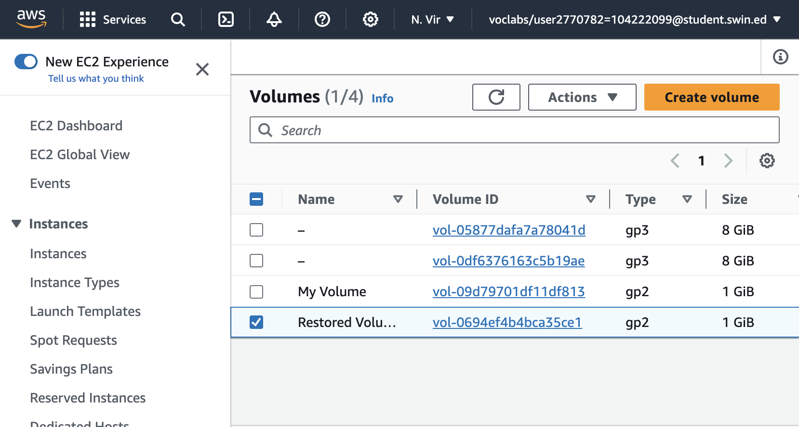

50. In the **Actions** menu, select **Attach volume**

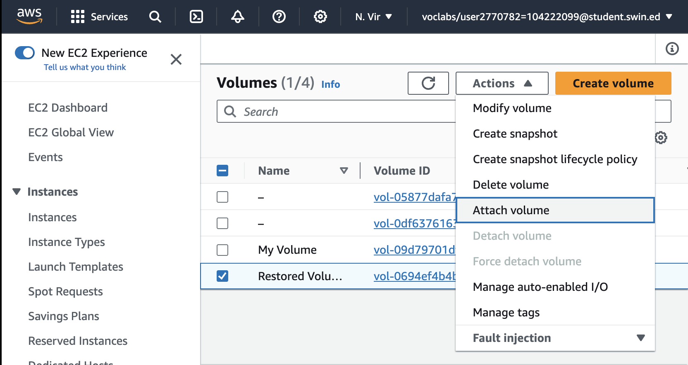

51. Choose the **Instance** field, then select the (Lab) instance that appears.

Note that the **Device** field is set to */dev/sdg*. You will use this device identifier in a later task.

52. Choose Attach volume

The volume state is now in-use.

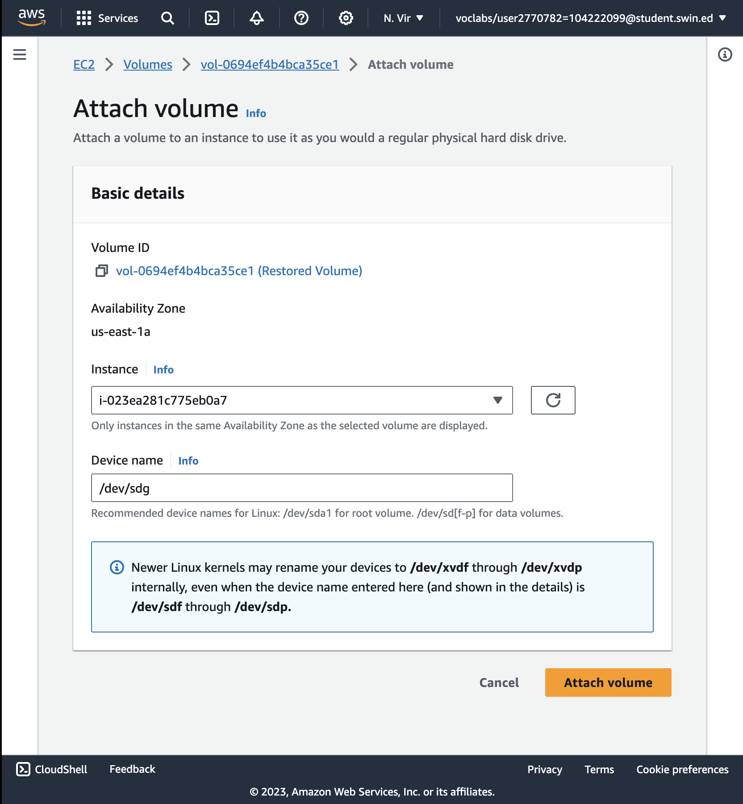

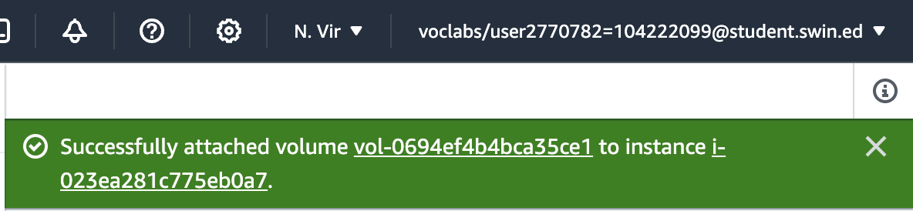

Successfully attached volume

**Mount the Restored Volume**

53. Create a directory for mounting the new storage volume:



54. Mount the new volume:



55. Verify that volume you mounted has the file that you created earlier.



END LAB.